**Class Practice – 5 (Univariate Analysis)**

**MIS 64038**

1. Plot the histogram using ggplot()

ggplot(cars, aes(hwy)) + geom_histogram()

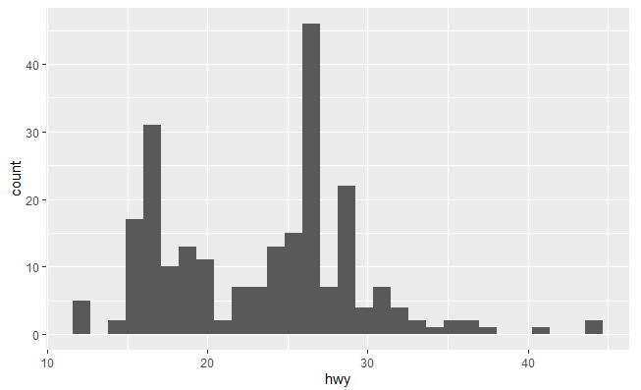

1. Plot the distribution of the variables using geom_freqpoly()

ggplot(cars, aes(hwy)) + geeom_freqpoly()

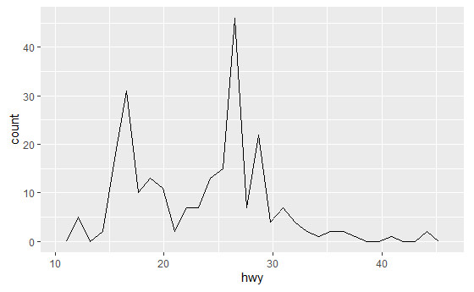

1. Plot box plot using geom_boxplot()

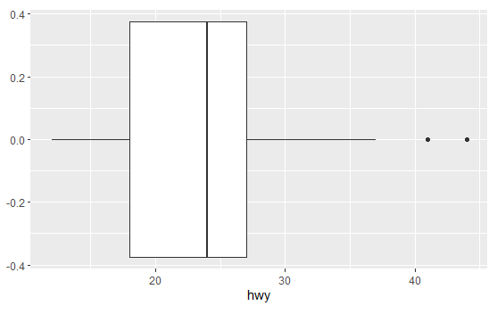

1. What is the purpose of Histograms and Density plot?

To get a sense of the variation in one variable. It can also be a test for the normality of the variable.

1. Name another Univariate plot?

Dot plot.

1. Plot the following using ggplot() + facet_wrap()

ggplot(mpg, aes(cty, fill = drv)) + geom_histogram(binwidth = 0.5) + facet_wrap(~drv, ncol = 1)

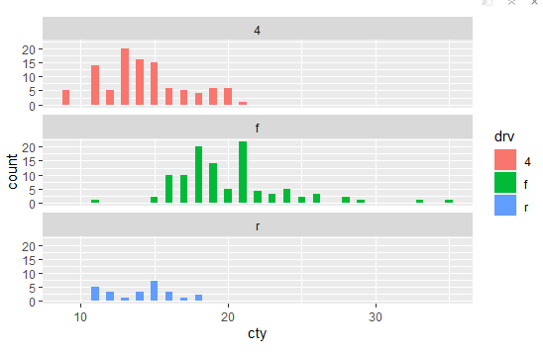

1. Plot the following graph:

